|  |
| --- |
| Experiment No. 7 |
| Program for data structure using built in function for link list, stack and queues |
| Date of Performance: |
| Date of Submission: |

**Experiment No. 7**

**Title:** Program for data structure using built in function for link list, stack and queues

**Aim:** To study and implement data structure using built in function for link list, stack and queues

**Objective:** To introduce data structures in python

**Theory:**

Stacks -the simplest of all data structures, but also the most important. A stack is a collection of objects that are inserted and removed using the LIFO principle. LIFO stands for “Last In First Out”. Because of the way stacks are structured, the last item added is the first to be removed, and vice-versa: the first item added is the last to be removed.

Queues – essentially a modified stack. It is a collection of objects that are inserted and removed according to the FIFO (First In First Out) principle. Queues are analogous to a line at the grocery store: people are added to the line from the back, and the first in line is the first that gets checked out – BOOM, FIFO!

Linked Lists

The Stack and Queue representations I just shared with you employ the python-based list to store their elements. A python list is nothing more than a dynamic array, which has some disadvantages.

The length of the dynamic array may be longer than the number of elements it stores, taking up precious free space.

Insertion and deletion from arrays are expensive since you must move the items next to them over

Using Linked Lists to implement a stack and a queue (instead of a dynamic array) solve both of these issues; addition and removal from both of these data structures (when implemented with a linked list) can be accomplished in constant O(1) time. This is a HUGE advantage when dealing with lists of millions of items.

Linked Lists – comprised of ‘Nodes’. Each node stores a piece of data and a reference to its next and/or previous node. This builds a linear sequence of nodes. All Linked Lists store a head, which is a reference to the first node. Some Linked Lists also store a tail, a reference to the last node in the list.

**Program:**

list = [10,20,30]

print("Traversing the list:")

for element in list:

print(element, end=" ")

print()

list.insert(4, 40)

print("List after insertion:",list)

list.append(50)

list.append(60)

print("List after append:",list)

list.remove(20)

print("List after removal:",list)

index_replace = 1

replace_element = 25

list.remove(list[index_replace])

list.insert(index_replace, replace_element)

print("List after replacement:",list)

element_search = 25

element_index = list.index(element_search)

print(f"Index of {element_search}:", element_index)

list_size = len(list)

print("Size of the list:", list_size)

**Output:**

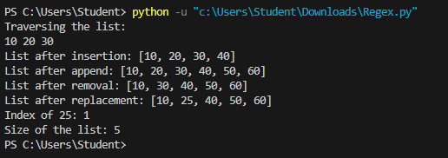

**Conclusion:**

1. Linked List: Implemented using a Node class and a LinkedList class. It provides methods for appending elements and displaying the list.

2. Stack: Implemented using a list as the underlying data structure. It provides methods for pushing, popping, and peeking elements.

3. Queue: Implemented using a list as the underlying data structure. It provides methods for enqueueing, dequeuing, and peeking elements. These data structures are fundamental building blocks in computer science and are used extensively in various applications. Understanding their implementation and usage is essential for any programmer.